## Introduction

The global COVID-19 outbreak has had a significant impact on the world. As of May 2021, there are over 164 million confirmed cases and 3 million deaths (World Health Organization, 2021). This pandemic has disrupted not only healthcare, but also social and economic activities, as well as international travel.

The development of vaccines for COVID-19 has been a major milestone in the fight against the pandemic. Clinical trials have established the efficacy of COVID-19 vaccines, resulting in a significant reduction in cases and deaths (Voysey et al., 2021). The global vaccine rollout has been successful, with over 1.5 billion doses administered as of May 2021 (Our World in Data, 2021). However, despite the progress made in vaccine administration, there is still a long way to go before the world can fully recover from the pandemic.

Therefore, it is important to analyze and understand the data related to COVID-19 and COVID-19 vaccines, as well as to continue researching and developing new treatments and vaccines to combat the virus. This visualization project provides an in-depth overview of the COVID-19 pandemic and vaccination progress worldwide, using publicly available data sources such as the GitHub repository by Our World in Data (2021) and the Kaggle dataset by Preda (2021). The project is intended for healthcare professionals, policymakers, and the general public who can benefit from the insights and information provided by the visualization. By gaining a deeper understanding of the data, we can continue to make informed decisions to help stop the spread of the virus and ultimately save lives.

## Use of different types of vaccines

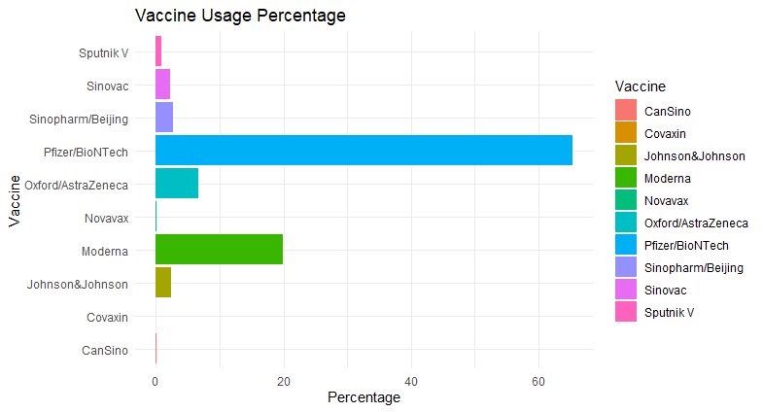

The graph displays the total number and percentage of vaccinations for different vaccine types. Pfizer/BioNTech is the most widely administered vaccine, accounting for 65.37% of the total number of vaccinations. Moderna and Oxford/AstraZeneca are also popular, with vaccination rates of 19.93% and 6.71%, respectively. Other vaccines such as Johnson & Johnson, Sinopharm/Beijing, Sinovac, and Sputnik V have also been administered, albeit in smaller quantities. This data can be valuable in providing insights for future vaccine inoculation efforts and resource allocation.

As shown in the figure above, the usage of Pfizer/BioNTech vaccine has consistently increased over time, occupying a significant proportion within the same time interval. Moderna vaccine ranks second, with a noticeable but comparatively smaller increase in usage since July 2021. Oxford/AstraZeneca vaccine comes in third with a relatively minor increase in usage from April to July 2021, and no significant change thereafter. Other types of vaccines have a very small proportion during this period and show no significant change in the long run.

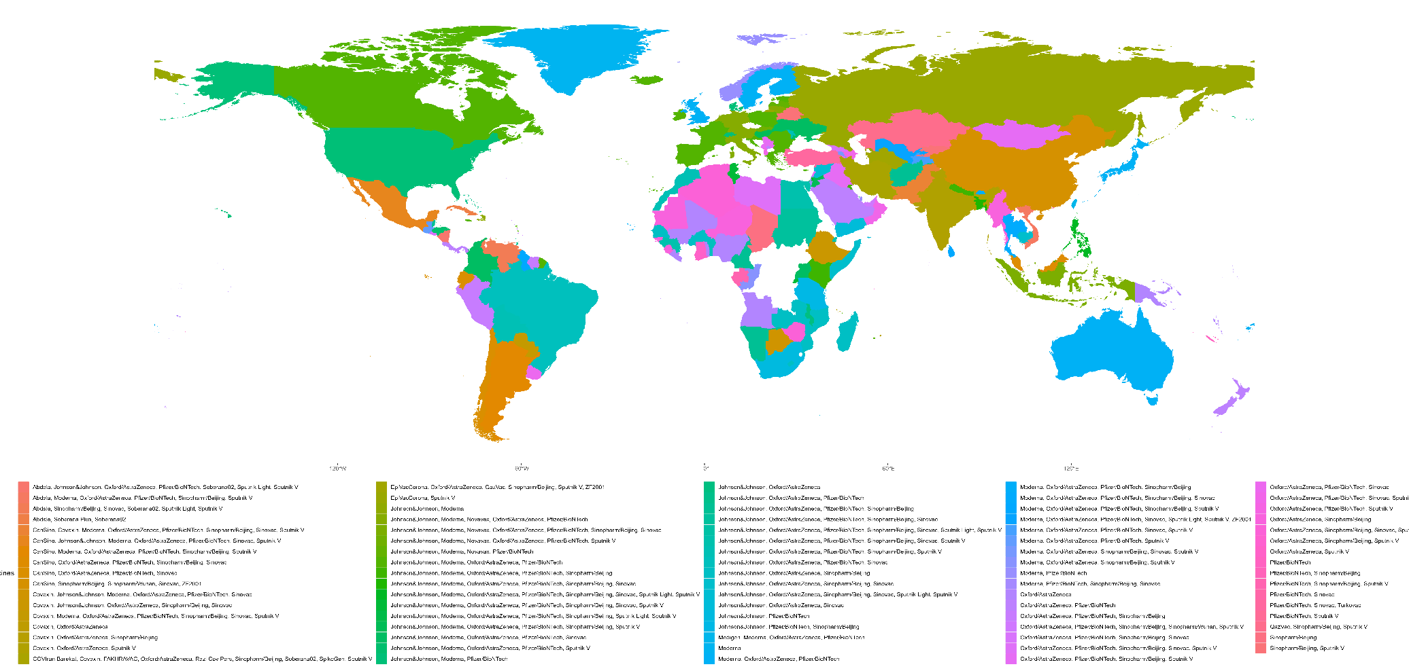

The figure presented above depicts the usage of various types of vaccines across different countries worldwide. It is evident that a majority of countries have employed a mix of vaccine combinations in order to combat COVID-19. Among the different vaccine combinations, "Pfizer/BioNTech" and "Moderna, Oxford/AstraZeneca" vaccines have been used extensively, with higher adoption rates compared to other vaccine combinations. In countries where only one vaccine type has been used, "Pfizer/BioNTech" has been the most widely used vaccine.

## Relationship between Variables

## References

Our World in Data. (2021, May 23). Coronavirus (COVID-19) Vaccinations. <https://ourworldindata.org/covid-vaccinations>

Preda, G. (2021). Covid-19 World Vaccination Progress. <https://www.kaggle.com/gpreda/covid-world-vaccination-progress>

Voysey, M., Clemens, S. A. C., Madhi, S. A., Weckx, L. Y., Folegatti, P. M., Aley, P. K., Angus, B., Baillie, V. L., Barnabas, S. L., Bhorat, Q. E., Bibi, S., Briner, C., Cicconi, P., Collins, A. M., Colin-Jones, R., Cutland, C. L., Darton, T. C., Dheda, K., Douglas, A. D., … Hill, A. V. S. (2021). Safety and efficacy of the ChAdOx1 nCoV-19 vaccine (AZD1222) against SARS-CoV-2: An interim analysis of four randomised controlled trials in Brazil, South Africa, and the UK. The Lancet, 397(10269), 99-111. <https://doi.org/10.1016/S0140-6736(20)32661-1>

World Health Organization. (2021, May 24). WHO Coronavirus Disease (COVID-19) Dashboard. <https://covid19.who.int/>